EDEXCEL 2003  DISPATCH 1 | CANDIDATE SHEET | SYLLABUS 1387/1388
MATHEMATICS GCSE | NEWSPAPER COMPARISONS | F, I & H


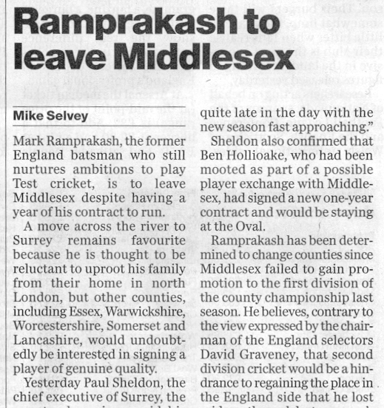
Extracts from the front pages of three newspapers are shown below.

Clearly there are differences in content and style between these three extracts.

There are differences between newspapers.

Your task is to choose some newspapers, analyse them for content and style and make comparisons between them.

Your analysis could consider, for instance,

- the amounts of space devoted to different items, such as sport, headlines, advertisements, news etc..

- the relative importance, status and space given to various items,
- the sizes, number of pages, area of print and cost of different newspapers,
- the readability, in terms of language levels, evidenced in different newspapers.

You may choose as many different newspapers as you wish. However, credit will be awarded more for quality and variation of your analysis and the appropriateness of your design and methods of presentation, rather than for undue repetition

